Resultados Finales

**Kmeans**

Boundary

ODS: F( 0.71, 0.41 ) = 0.52 [th = 2.00]

OIS: F( 0.74, 0.46 ) = 0.57

Area_PR = 0.16

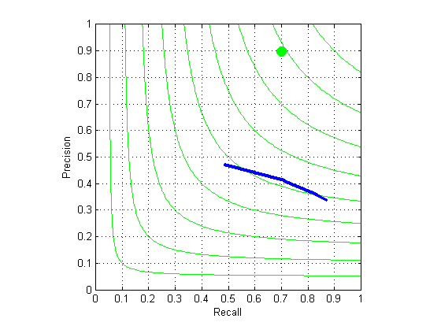

GMM

Boundary

ODS: F( 0.68, 0.38 ) = 0.49 [th = 2.00]

OIS: F( 0.75, 0.44 ) = 0.55

Area_PR = 0.15

